Unijunction Transistor
23 May 2017
8:01

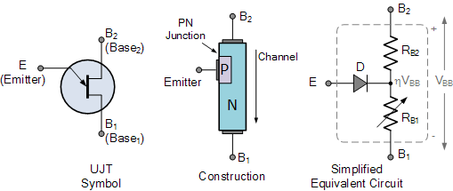
Unijunction Transistor
The Unijunction Transistor or UJT for short, is another solid state three terminal device that can be used in gate pulse, timing circuits and trigger generator applications to switch and control either thyristors and triacs for AC power control type applications.

Like diodes, unijunction transistors are constructed from separate P-type and N-type semiconductor materials forming a single (hence its name Uni-Junction) PN-junction within the main conducting N-type channel of the device.
Although the Unijunction Transistor has the name of a transistor, its switching characteristics are very different from those of a conventional bipolar or field effect transistor as it can not be used to amplify a signal but instead is used as a ON-OFF switching transistor. UJT’s have unidirectional conductivity and negative impedance characteristics acting more like a variable voltage divider during breakdown.
Like N-channel FET’s, the UJT consists of a single solid piece of N-type semiconductor material forming the main current carrying channel with its two outer connections marked as Base 2 ( B2 ) and Base 1 ( B1 ). The third connection, confusingly marked as the Emitter ( E ) is located along the channel. The emitter terminal is represented by an arrow pointing from the P-type emitter to the N-type base.
The Emitter rectifying p-n junction of the unijunction transistor is formed by fusing the P-type material into the N-type silicon channel. However, P-channel UJT’s with an N-type Emitter terminal are also available but these are little used.
The Emitter junction is positioned along the channel so that it is closer to terminal B2than B1. An arrow is used in the UJT symbol which points towards the base indicating that the Emitter terminal is positive and the silicon bar is negative material. Below shows the symbol, construction, and equivalent circuit of the UJT.
Unijunction Transistor Symbol and Construction

Notice that the symbol for the unijunction transistor looks very similar to that of the junction field effect transistor or JFET, except that it has a bent arrow representing the Emitter( E ) input. While similar in respect of their ohmic channels, JFET’s and UJT’s operate very differently and should not be confused.
So how does it work? We can see from the equivalent circuit above, that the N-type channel basically consists of two resistors RB2 and RB1 in series with an equivalent (ideal) diode, D representing the p-n junction connected to their center point. This Emitter p-n junction is fixed in position along the ohmic channel during manufacture and can therefore not be changed.
Resistance RB1 is given between the Emitter, E and terminal B1, while resistance RB2 is given between the Emitter, E and terminal B2. As the physical position of the p-n junction is closer to terminal B2 than B1 the resistive value of RB2 will be less than RB1.
The total resistance of the silicon bar (its Ohmic resistance) will be dependent upon the semiconductors actual doping level as well as the physical dimensions of the N-type silicon channel but can be represented by RBB. If measured with an ohmmeter, this static resistance would typically measure somewhere between about 4kΩ and 10kΩ’s for most common UJT’s such as the 2N1671, 2N2646 or the 2N2647.
These two series resistances produce a voltage divider network between the two base terminals of the unijunction transistor and since this channel stretches from B2 to B1, when a voltage is applied across the device, the potential at any point along the channel will be in proportion to its position between terminals B2 and B1. The level of the voltage gradient therefore depends upon the amount of supply voltage.
When used in a circuit, terminal B1 is connected to ground and the Emitter serves as the input to the device. Suppose a voltage VBB is applied across the UJT between B2 and B1 so that B2 is biased positive relative to B1. With zero Emitter input applied, the voltage developed across RB1 (the lower resistance) of the resistive voltage divider can be calculated as:
Unijunction Transistor RB1 Voltage


For a unijunction transistor, the resistive ratio of RB1 to RBB shown above is called the intrinsic stand-off ratio and is given the Greek symbol: η (eta). Typical standard values of η range from 0.5 to 0.8 for most common UJT’s.
If a small positive input voltage which is less than the voltage developed across resistance, RB1 ( ηVBB ) is now applied to the Emitter input terminal, the diode p-n junction is reverse biased, thus offering a very high impedance and the device does not conduct. The UJT is switched “OFF” and zero current flows.
However, when the Emitter input voltage is increased and becomes greater than VRB1 (or ηVBB + 0.7V, where 0.7V equals the p-n junction diode volt drop) the p-n junction becomes forward biased and the unijunction transistor begins to conduct. The result is that Emitter current, ηIE now flows from the Emitter into the Base region.
The effect of the additional Emitter current flowing into the Base reduces the resistive portion of the channel between the Emitter junction and the B1 terminal. This reduction in the value of RB1 resistance to a very low value means that the Emitter junction becomes even more forward biased resulting in a larger current flow. The effect of this results in a negative resistance at the Emitter terminal.
Likewise, if the input voltage applied between the Emitter and B1 terminal decreases to a value below breakdown, the resistive value of RB1 increases to a high value. Then the Unijunction Transistor can be thought of as a voltage breakdown device.
So we can see that the resistance presented by RB1 is variable and is dependant on the value of Emitter current, IE. Then forward biasing the Emitter junction with respect to B1 causes more current to flow which reduces the resistance between the Emitter, E and B1.
In other words, the flow of current into the UJT’s Emitter causes the resistive value of RB1 to decrease and the voltage drop across it, VRB1 must also decrease, allowing more current to flow producing a negative resistance condition.
Unijunction Transistor Applications
Now that we know how a unijunction transistor works, what can they be used for. The most common application of a unijunction transistor is as a triggering device for SCR’sand Triacs but other UJT applications include sawtoothed generators, simple oscillators, phase control, and timing circuits. The simplest of all UJT circuits is the Relaxation Oscillator producing non-sinusoidal waveforms.
In a basic and typical UJT relaxation oscillator circuit, the Emitter terminal of the unijunction transistor is connected to the junction of a series connected resistor and capacitor, RC circuit as shown below.
Unijunction Transistor Relaxation Oscillator
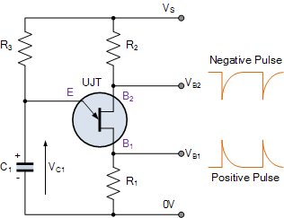

When a voltage (Vs) is firstly applied, the unijunction transistor is “OFF” and the capacitor C1 is fully discharged but begins to charge up exponentially through resistor R3. As the Emitter of the UJT is connected to the capacitor, when the charging voltage Vc across the capacitor becomes greater than the diode volt drop value, the p-n junction behaves as a normal diode and becomes forward biased triggering the UJT into conduction. The unijunction transistor is “ON”. At this point the Emitter to B1 impedance collapses as the Emitter goes into a low impedance saturated state with the flow of Emitter current through R1 taking place.
As the ohmic value of resistor R1 is very low, the capacitor discharges rapidly through the UJT and a fast rising voltage pulse appears across R1. Also, because the capacitor discharges more quickly through the UJT than it does charging up through resistor R3, the discharging time is a lot less than the charging time as the capacitor discharges through the low resistance UJT.
When the voltage across the capacitor decreases below the holding point of the p-n junction ( VOFF ), the UJT turns “OFF” and no current flows into the Emitter junction so once again the capacitor charges up through resistor R3 and this charging and discharging process between VON and VOFF is constantly repeated while there is a supply voltage, Vs applied.
UJT Oscillator Waveforms
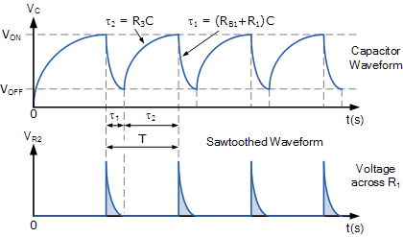

Then we can see that the unijunction oscillator continually switches “ON” and “OFF” without any feedback. The frequency of operation of the oscillator is directly affected by the value of the charging resistance R3, in series with the capacitor C1 and the value of η. The output pulse shape generated from the Base1 (B1) terminal is that of a sawtooth waveform and to regulate the time period, you only have to change the ohmic value of resistance, R3 since it sets the RC time constant for charging the capacitor.
The time period, T of the sawtoothed waveform will be given as the charging time plus the discharging time of the capacitor. As the discharge time, τ1 is generally very short in comparison to the larger RC charging time, τ2 the time period of oscillation is more or less equivalent to T ≅ τ2. The frequency of oscillation is therefore given by ƒ = 1/T.
UJT Oscillator Example No1
The data sheet for a 2N2646 Unijunction Transistor gives the intrinsic stand-off ratio η as 0.65. If a 100nF capacitor is used to generate the timing pulses, calculate the timing resistor required to produce an oscillation frequency of 100Hz.
1. The timing period is given as:
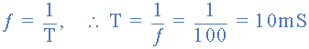
2. The value of the timing resistor, R3 is calculated as:
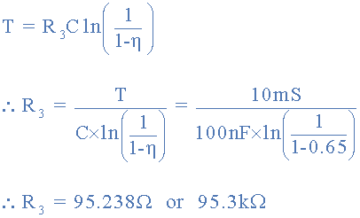

Then the value of charging resistor required in this simple example is calculated as 95.3kΩ’s to the nearest preferred value. However, there are certain conditions required for the UJT relaxation oscillator to operate correctly as the resistive value of R3 can be too large or too small.
For example, if the value of R3 was too large, (Megohms) the capacitor may not charge up sufficiently to trigger the Unijunction’s Emitter into conduction but must also be large enough to ensure that the UJT switches “OFF” once the capacitor has discharged to below the lower trigger voltage.
Likewise if the value of R3 was too small, (a few hundred Ohms) once triggered the current flowing into the Emitter terminal may be sufficiently large to drive the device into its saturation region preventing it from turning “OFF” completely. Either way the unijunction oscillator circuit would fail to oscillate.
UJT Speed Control Circuit
One typical application of the unijunction transistor circuit above is to generate a series of pulses to fire and control a thyristor. By using the UJT as a phase control triggering circuit in conjunction with an SCR or Triac, we can adjust the speed of a universal AC or DC motor as shown.
Unijunction Transistor Speed Control
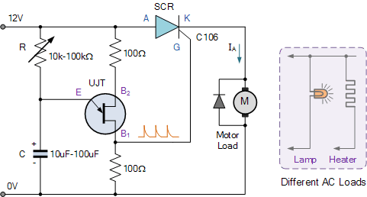

Using the circuit above, we can control the speed of a universal series motor (or whichever type of load we want, heaters, lamps, etc) by regulating the current flowing through the SCR. To control the motors speed, simply change the frequency of the sawtooth pulse, which is achieved by varying the value of the potentiometer.
Unijunction Transistor Summary
We have seen that a Unijunction Transistor or UJT for short, is an electronic semiconductor device that has only one p-n junction within a N-type (or P-type) lightly doped ohmic channel. The UJT has three terminals one labelled Emitter (E) and two Bases (B1 and B2).
Two ohmic contacts B1 and B2 are attached at each ends of the semiconductor channel with the resistance between B1 and B2, when the emitter is open circuited being called the interbase resistance, RBB. If measured with an ohmmeter, this static resistance would typically measure somewhere between about 4kΩ and 10kΩ’s for most common UJT’s.
The ratio of RB1 to RBB is called the intrinsic stand-off ratio, and is given the Greek symbol: η (eta). Typical standard values of η range from 0.5 to 0.8 for most common UJT’s.
The unijunction transistor is a solid state triggering device that can be used in a variety of circuits and applications, ranging from the firing of thyristors and triacs, to the use in sawtooth generators for phase control circuits.The negative resistance characteristic of the UJT also makes it very useful as a simple relaxation oscillator.
When connected as a relaxation oscillator, it can oscillate independently without a tank circuit or complicated RC feedback network. When connected this way, the unijunction transistor is capable of generating a train of pulses of varying duration simply by varying the values of a single capacitor, (C) or resistor, (R).
Commonly available unijunction transistors include the 2N1671, 2N2646, 2N2647, etc, with the 2N2646 being the most popular UJT for use in pulse and sawtooth generators and time delay circuits. Other types of unijunction transistor devices available are called Programmable UJTs, which can have their switching parameters set by external resistors. The most common Programmable Unijunction Transistors are the 2N6027 and the 2N6028.

